SOFTWARE ENGINEERING AND PROJECT MANAGEMENT
2. Requirements Analysis and Cost Estimation
2.1 Software Requirements: Functional & non-functional – user-system requirement engineering process – feasibility studies – elicitation – validation & management – software prototyping – S/W documentation – Analysis and modelling Requirement Elicitation, Software requirement specification (SRS) 3Ps (people, product and process) Process and Project metrics Software Project Estimation: LOC, FP, Empirical Estimation Models - COCOMO II Model
PAST QUESTIONS:
- Explain functional and non-functional requirements. (M23, D23)
- Elaborate COCOMO model for Cost estimation. (M23, D23, D24)
- Develop the SRS of University Management system. (M23)
- Develop the SRS of Hospital Management system. (D23, D24)
- What is the importance of requirement analysis? Explain different Requirement engineering tasks. (M24)
- Prepare SRS for Railway Reservation System. (M24)
- What is cost estimation? Assume that a system for simple student registration in a course is planned to be developed and its estimated size is approximately 10,000 lines of code. The organization is proposed to pay Rs 25000/month to software engineers. Compute the development effort, development time? (D24)
NOTES:

*Functional & Non-Functional requirements :-
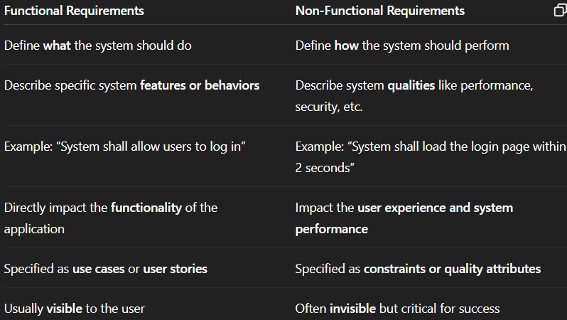

*Requirement Engineering Task :-
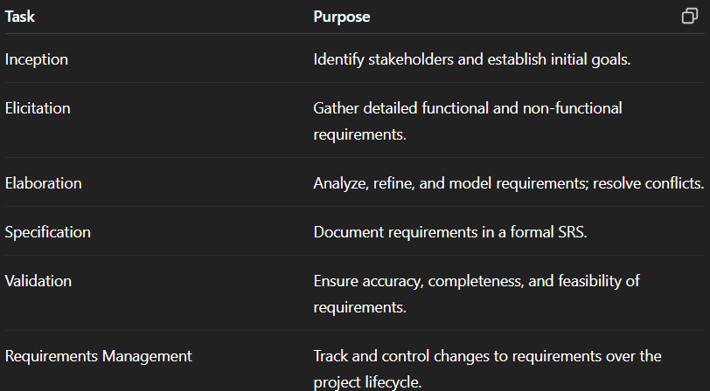

*COCOMO :-
Constructive Cost Model (COCOMO) is a procedural cost estimate model for Software Projects and is often used as a process of reliably predicting the various parameters associated with making a project such as size, effort, cost, time, and quality.
Types of COCOMO models:
- Basic COCOMO model - The Basic COCOMO model is a straightforward way to estimate the effort needed for a software development project. It uses a simple mathematical formula to predict how many person-months of work are required based on the size of the project, measured in thousands of lines of code (KLOC).
Formula:
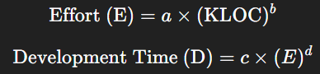
Where, E -> Effort; KLOC -> Kilo lines of code; a, b, c, d -> constraints determined by the category of the project.
- Intermediate COCOMO model - The Basic COCOMO model assumes effort depends only on Lines of Code (KLOC) and fixed constants based on project type. However, in reality, factors like reliability, team experience, and capability also impact effort. These are known as Cost Drivers or multipliers. The Intermediate COCOMO model accounts for this by using 15 cost drivers to provide more accurate cost estimation.
Formula:

Where, EAF -> Effort Adjustment Factor.
- Detailed COCOMO model - Detailed COCOMO goes beyond Basic and Intermediate COCOMO by diving deeper into project-specific factors. Detailed COCOMO provides a highly accurate estimation of effort, time, and cost for software projects. It's like zooming in on a project's unique characteristics to get a clearer picture of what it will take to complete it successfully.
Divides the system into subsystems or modules.
Applies the intermediate model to each module.
Advantages –
- Provides structured and reliable estimates.
- Supports project planning and budgeting.
- Adaptable using cost drivers.
- Detailed models offer phase-wise tracking.
Disadvantages –
- Based on KLOC, which may not be known early in the project.
- May not suit modern development practices (Agile, DevOps, reuse).
- Assumes waterfall model and homogeneous team skillsets.

*SRS :-
